**Name :Yadwinder Singh**

**UID : 23BCS10091**

**Class: 622-B**

**1️⃣ Project Structure**

frontend/

├── Dockerfile

├── package.json

├── package-lock.json

└── src/

**2️⃣ Multi-Stage Dockerfile**

# ---------- Stage 1: Build React app ----------

FROM node:18-alpine AS builder

# Set working directory

WORKDIR /app

# Copy dependencies first (for better caching)

COPY package*.json ./

# Install dependencies

RUN npm ci

# Copy rest of the source code

COPY . .

# Build the app for production

RUN npm run build

# ---------- Stage 2: Serve with Nginx ----------

FROM nginx:alpine

# Remove default nginx website

RUN rm -rf /usr/share/nginx/html/*

# Copy build files from the builder stage

COPY --from=builder /app/build /usr/share/nginx/html

# Expose port 80

EXPOSE 80

# Start nginx

CMD ["nginx", "-g", "daemon off;"]

**Build & Run Commands**

**Build the image**

docker build -t react-app-prod .

**Run the container**

**docker run -d -p 80:80 react-app-prod**

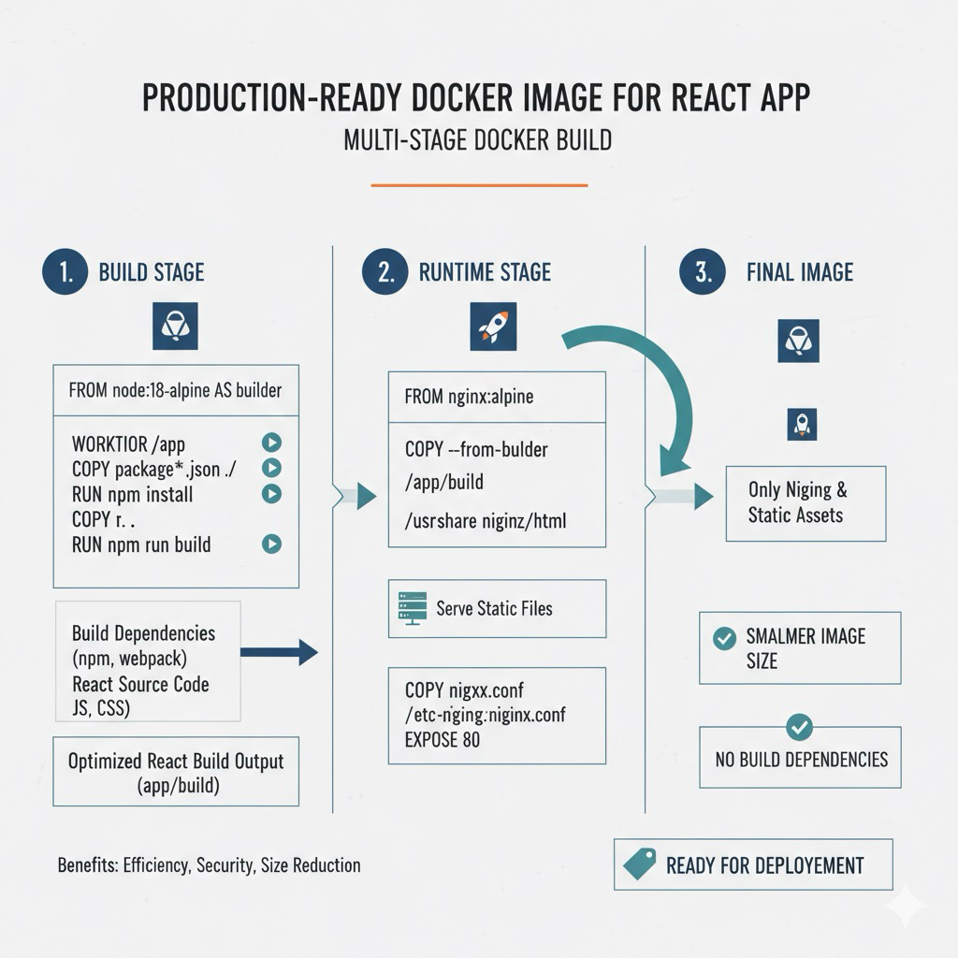**Output in Image Form :**